1 Warm up

**Is it possible to find true love on dating apps? Do you believe dating apps have killed romance? Are they safe?**



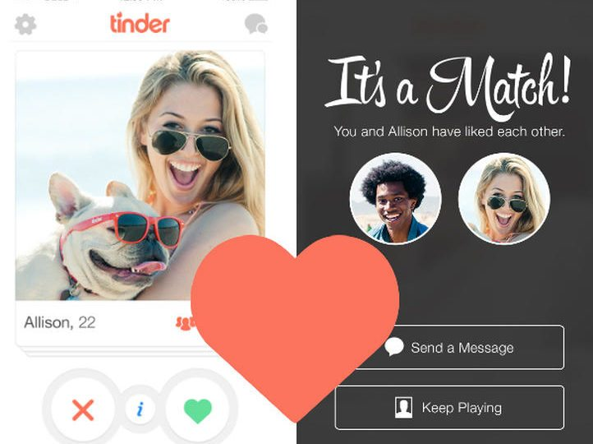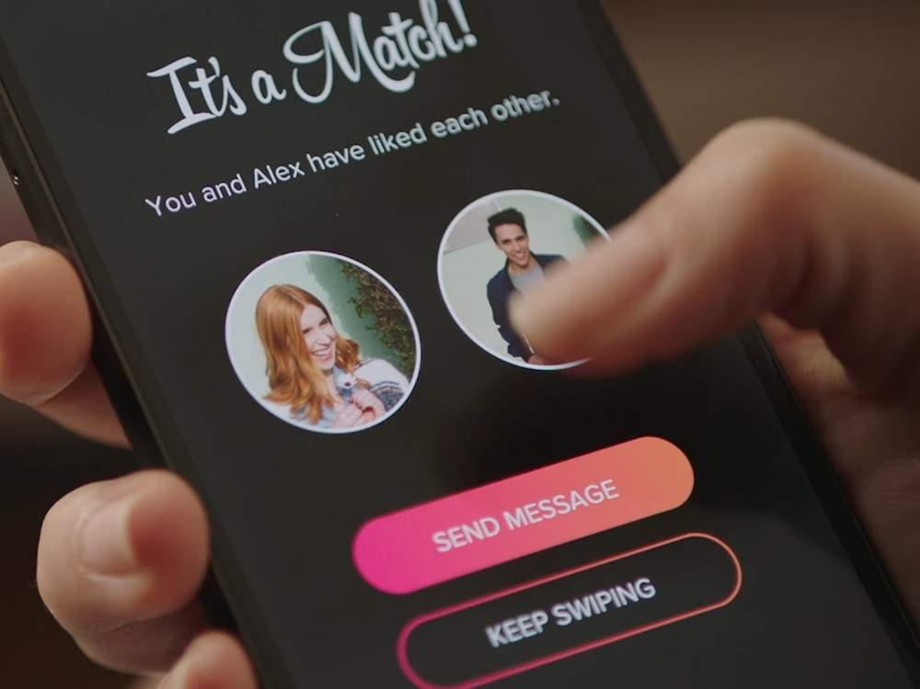

2 Listening https://www.youtube.com/watch?v=up4nejmEJ_k

**Watch a review of *Hand The DJ,* an episode of Black Mirror, and answer the following questions.**





1. How are couples paired up?

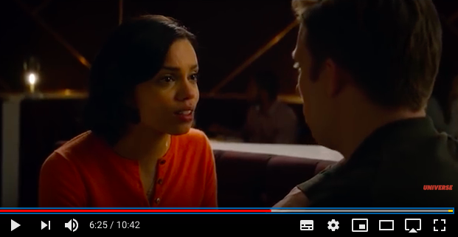



1. How can couples win the simulation? How does the app decide that Frank and Amy are 99.8% compatible with one another?

3 Listening

**Watch the video First dates USA:** [**https://www.youtube.com/watch?v=9yL-criH-OM**](https://www.youtube.com/watch?v=9yL-criH-OM)

**Task 1. General understanding.**

**1. Do the couple eat meat?**

a) Woody likes raw meat and Catherine is completely a vegan.

b) Woody is a meat-eater but Catherine is a vegetarian.

c) Woody is a carnivore but Catherine occasionally eats meet.

**2. How does Catherine feel about having been a bridesmaid for 7 times?**

a) She doesn’t matter not being the bride.

b) She is OK with that.

c) She doesn’t completely accept it.

**Task 2. General understanding. True or False.**

T - 1. Catherine’s relationships fail because she is too picky and a psychopath.

F -2. Catherine has been in many blind dates before.

T - 3. Catherine’s last relationship problems were making her get old.

F - 4. Catherine doesn’t like Woody’s beard.

T - 5. It is important for Woody that the couple look good together.

**Task 3.**

1. Why is the girl less fit than usual?